System Design

1. Database design

- User Collection.

{
_id: ObjectId,
name: String,
email: String,
passwordHash: String,

totalAttempts: Number,
totalSolved: Number,
accuracy: Number,

weakTopics: [String], // dynamically updated
createdAt: Date
}

- Problems Collection
{
_id: ObjectId,
title: String,
description: String,
difficulty: "Easy | Medium | Hard",
topics: [String],
constraints: {
nRange: String,
valueRange: String
},
createdBy: "admin | ai | user",
createdAt: Date
}

- Submissions Collection
{
id: ObjectId,
userId: ObjectId,
problemId: ObjectId,
code: String,
language: "C++",
result: "Accepted | TLE | WA | RE",
detectedApproach: "Brute | Greedy | DP | Graph | etc",
timeComplexity: String,
mayFailReason: String,
suggestedOptimal: String,
timeTaken: Number, // in seconds
createdAt: Date
}

-Hints Collection
{
id: ObjectId,
problemId: ObjectId,
low: String,
medium: String,
aggressive: String,
generatedBy: "AI | Cached",
createdAt: Date
}.

-> RelationShips
users_id – submission userId.
problems_id – submissions_problemId

2. API routes

1. Auth Routes.
Base: /api/auth

-> POST/register.
{
“name” : Satvik,
“email” : “agarwal@satvik.com”,
“password” : “123456”
}

Returns – JWT Tokens, Basic Profile.

-> POST/login.
Returns – JWT token, user summary stats.

-> GET/me.
Returns – user profile, totalAttempts, totalSolved, accuracy, weakTopics.

2. Problems Routes.
Base: /api/problem.
-> POST/ - Create Problem.

-> GET/ - Query params supported.
/api/problems?difficulty=Medium&topic=DP

-> GET/:id – Get full priblem details.

3. Arena Routes.
Base: /api/arena.

-> POST/generate-hint –
{
problemId : “...”,
level : :low | medium | aggressive”
}

Flow
- Check if hint cached in DB.
- If not -> call Gemini.
- Stores in hints collection.
- Returns hint.

-> POST: /submit
Body:
{
“problemId” : “...”,
“code” : “C++ code string”,
“language” : “cpp”,
“timetaken” : 320
}

Flow
- Send code to execution service.
- Run against.
- User test.
- boundary.
- worst case.
- Get result.
- Send result.
- Store Submission.
- Update user stats.
- Return analysis.

Response
{
“result” : “TLE”,
“detectedApproach” : “BruteForce”,
“timeComplexity” : “O(n^2)”,
“mayFailReason” : “___”,
“suggestedOptimal” : “User prefix sums”
}

4. Test Generator Routes.
{
“nRange” : “1 – 10000”,
“valueRange” : “10^9 to 10^9”,
“constraints” : “unique values”
}

Returns – worst Case, edge Case, boundary Case, large Random.

5. Dashboard Routes
Base: /api/dashboard

-> GET: /summary
Returns
{
“totalAttempts” : 45,
“accuracy” : 62,
“weakTopics” : [“DP”, “Graphs”]
}

-> GET: /attempts-over-time
{
{“date” : “2026-02-10”, “count” : 2},
{“date” : “2026-02-10”, “count” : 5}
}
Internal Architecture
Controllers/
Services/
routes/
middlewares/
utils

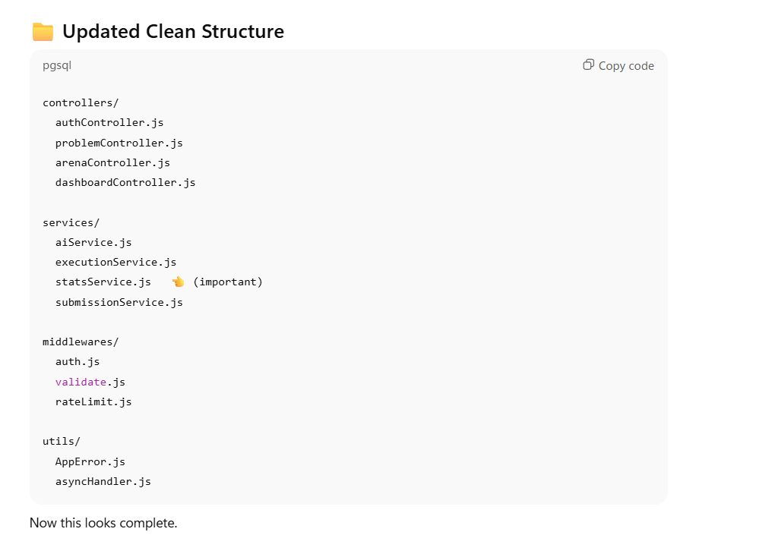
3. External Services & Integrations.

1. Code Execution Engine (Sandbox)
- Provider: Judge0 CE (via RapidAPI).
- Purpose: Safely runs user-submitted code without needing local Docker containers.
- Flow:
  - Backend sends source code + inputs to Judge0.
  - Judge0 returns stdout (output), stderr (errors), time_taken, and memory_used.
  - Fallback: If Judge0 is down, return a "Service Busy" error (fail-safe).

2. AI Smart Hint Engine
- Provider: Google Gemini API.
- Model: Gemini 1.5 Flash (optimized for speed/cost) or Pro.
- Constraint: Strict Rate Limiting applied to this service.
  - Limit: Max 5 "Generate Hint" requests per user/hour.
  - Reason: Prevents quota exhaustion and abuse.

3. Data Security & Validation
- Input Validation: Use Joi or Zod middleware to sanitise all code inputs before sending to Judge0 (prevent injection attacks).
- Environment Variables: Store all API Keys (RAPIDAPI_KEY, GEMINI_API_KEY) in .env file (never commit to GitHub).

4. The "AI & Logic" Section

  - Hint Generation: "System Prompt will accept Code Snippet + Problem Statement. It will be instructed to provide incremental hints (Low/Medium/Aggressive) without revealing the full solution."
  - Code Analysis: "After Judge0 execution, if result is not 'Accepted', send code + error to Gemini to generate mayFailReason and suggestedOptimal strategy."

2. The "Weakness Detection" Algorithm 📉
Your planning file says the app will "Recognize weakness" and your database has a weakTopics array. But you haven't said how the system decides a topic is "weak."
+2
- Add this bullet under Internal Architecture or Services:
  - Stats Service Logic: "If a user fails >3 problems with the tag 'DP' (Dynamic Programming) or has an accuracy < 40% in that tag, automatically add 'DP' to user.weakTopics."
+1

3. The "Judge0" Integration (Execution Engine) ⚙️
Your planning file says "Send code to execution service". Since we agreed to use Judge0 instead of Docker, you need to document this external dependency.
- Add this under a Tech Stack & Services heading:
  - Code Runner: Judge0 API (via RapidAPI).
  - Why: To securely execute C++ user code and return timeTaken and stdout for validation against test cases.
+1

4. Environment Variables (Security) 🔒
To show you are a "prod-ready" developer, explicitly list the keys you need.
- Add a small Configuration section:
  - GEMINI_API_KEY: For Hints and Analysis.
  - RAPIDAPI_KEY: For Judge0 execution.
  - MONGO_URI: Database connection.
  - JWT_SECRET: For Auth.

